TASK: Use AWS KMS to generate a data encryption key (DEK), encrypt a sensitive file with OpenSSL, store only the encrypted DEK with the ciphertext, and later recover the DEK via KMS to decrypt the file.

- Created a KMS key “imran-kms-demo”
- 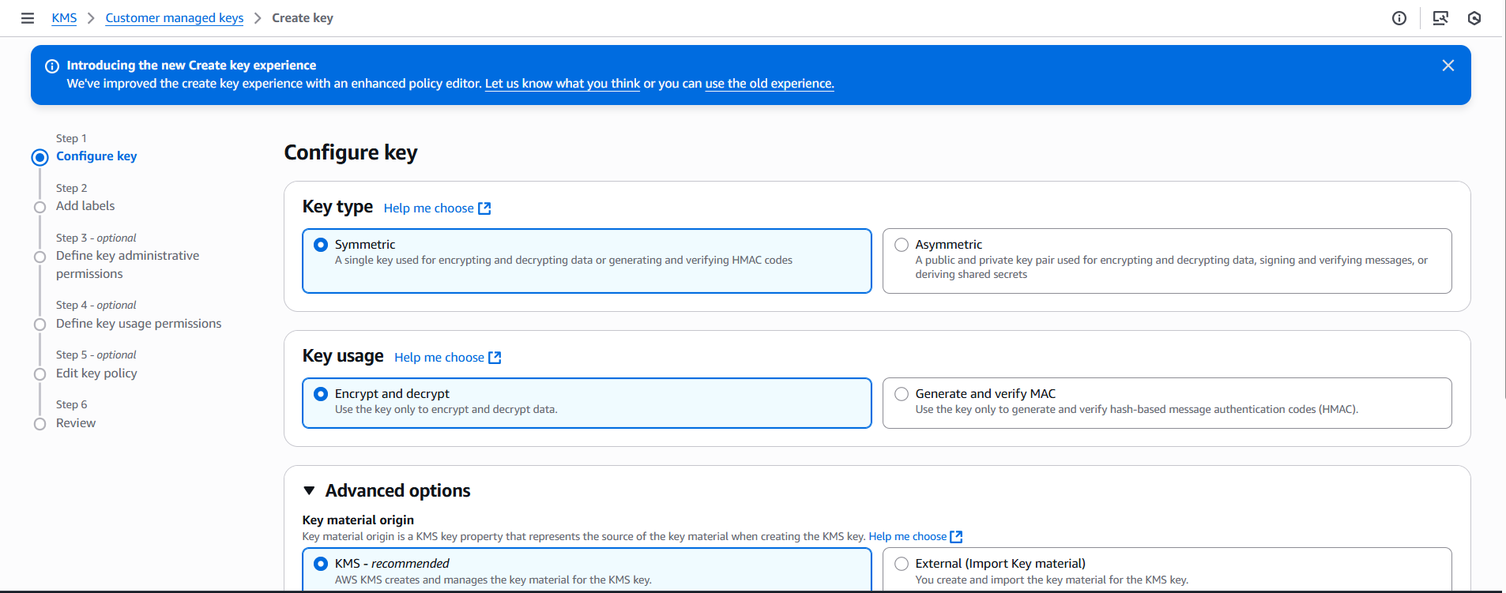
- Open gitbash or any cli, creating a file with my aws accounts passwords or credentials
- 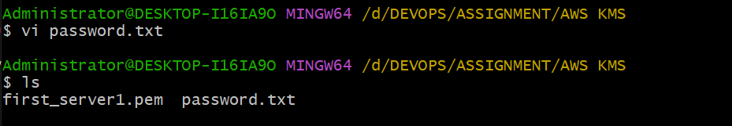
- 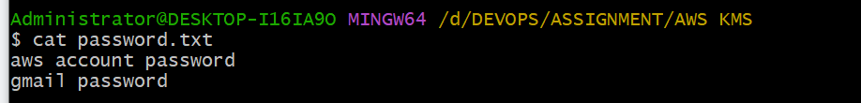
- Generate a KMS Data Key (DEK)
- aws kms generate-data-key --key-id alias/imran-kms-demo --key-spec AES_256 --region us-east-1
- 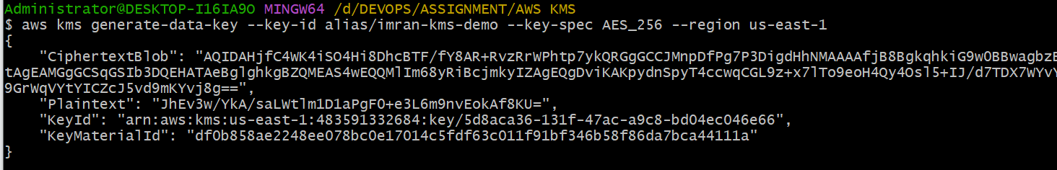
KMS returned:
- Plaintext (base64): the raw 256-bit data key, encoded
- CiphertextBlob (base64): the same data key, encrypted under your CMK
- KeyId: which CMK was used
- I redirected the JSON to keys.txt for reuse:
- aws kms generate-data-key --key-id alias/imran-kms-demo --key-spec AES_256 --region us-east-1 > keys.txt
- 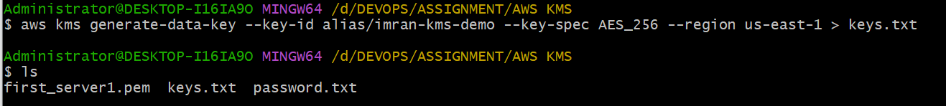
- Create a binary file with the plaintext DEK
- You base64-decoded the Plaintext into datakey (binary):
- datakey looks like gibberish in cat because it’s raw bytes (expected).
- 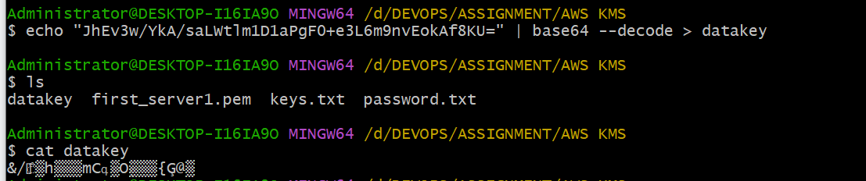
- Create a binary file with the encrypted DEK
- You base64-decoded the CiphertextBlob into encrypted-datakey:
- This file is safe to store next to your ciphertext. It can only be turned back into the plaintext key by KMS (and only if caller is authorized).
- Echo “copy the ciphertextbob” | base64 --decode > encrypted-datakey
- 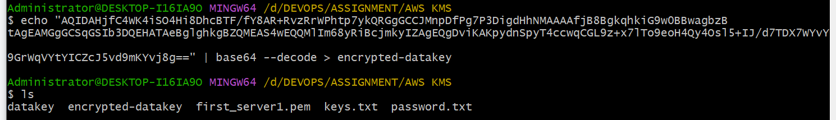
- Encrypt your secrets with OpenSSL
- openssl enc -in ./password.txt -out ./imran-passwords-encrypted.txt -e -aes256 -k fileb://./datakey
- Result: imran-passwords-encrypted.txt (unreadable binary).
- 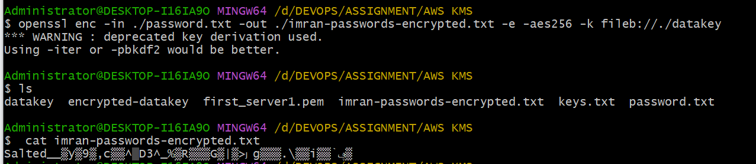
- (Later) Recover the plaintext DEK from KMS
- You asked KMS to decrypt the stored encrypted DEK:
- aws kms decrypt --ciphertext-blob fileb://./encrypted-datakey --region us-east-1
- KMS returned the same Plaintext (base64) DEK you had originally.

- 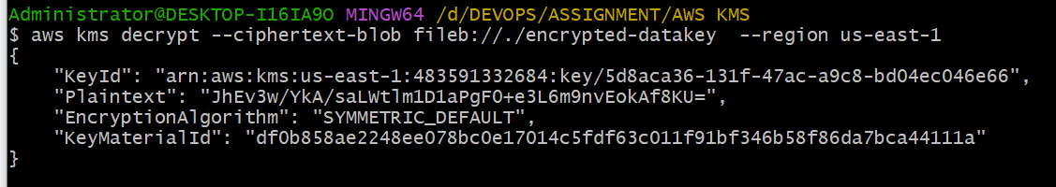
- Decrypt your file
- You used OpenSSL with the same parameters to get back the cleartext:
- openssl enc -in ./imran-passwords-encrypted.txt -out ./imran-passwords-decrypted.txt -d -aes256 -k fileb://./datakey
- imran-passwords-decrypted.txt matched your original password.txt ✅
- 